

**Prepared By:**

**Jayrajsinh Mourya**

**Oct 30, 2023**

**Version: 1.3**

**Submitted To:**   
**PathQuest Global Solution**

**Bill posting**

# Document Control

|  |  |  |
| --- | --- | --- |
| **Security Set:** | Confidential | |
| **Issue Date:** | August 18, 2023 | |
| **Current Version** | 1.1 | |
| **Author(s):** | **Name** | **Title** |
| Jayrajsinh Mourya | Business Analyst |
| **Issuer(s):** | **Name** | **Title** |
| Mr. Suresh Kalal & Ms. Shimoli Shah | CTO & AVP |
| Submitted to:  Aniket Thakkar, Rounak Shah, Indraxy Jape, Manish Prajapati, Urvish Kadia, Suresh Kalal, Shimoli shah, Krunal Shah. | | |

# Version History

|  |  |  |  |  |
| --- | --- | --- | --- | --- |
| **Version No.** | **Author** | **Issuer** | **Updated Date** | **Change / Update** |
| 1.0 | Vaibhav Shukla | Mr. Suresh Kalal & Ms. Shimoli Shah | 04/07/2023 | Draft Version |
| 1.1 | Vaibhav Shukla | Mr. Suresh Kalal & Ms. Shimoli Shah | 24/07/2023 | Few stories updated. |
| 1.2 | Vaibhav Shukla | Mr. Suresh Kalal & Ms. Shimoli Shah | 18/08/2023 | Minor changes |
| 1.3 | Jayrajsinh Mourya | Mr. Suresh Kalal & Ms. Shimoli Shah | 31/10/2023 | Drafted new document with all the latest updates |
| 1.4 | Jayrajsinh Mourya | Mr. Suresh Kalal & Ms. Shimoli Shah | 15/10/2023 | Added the feedback in document |

**Table of Contents**

Document Control 2

Version History 2

Listing Screen 4

Table 7

Multi Selection 8

View Mode 9

Edit Mode 12

Create >> Account Payable 13

Create >> Account Adjustment 15

**Bill Posting**

## **Listing Screen**

In Bill Posting screen, user can manage and process bills efficiently. Here the screen shall display the Bills coming from three different sources: "Cloud," "Email," and "File Upload." After completing the Indexing and OCR.

Once automation is done, the bills will be considered as “Account payable” bill and listed down in the bill posting screen. The journey of bill up to posting will be shown in this screen.

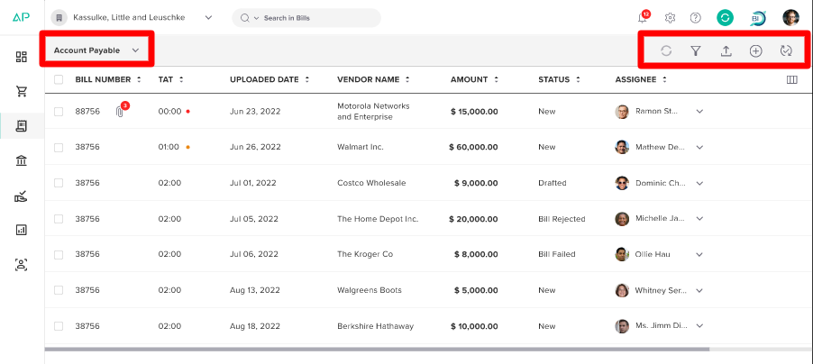

The Bill posting listing screen should contain following option in header as shown above

1. Process Selection
2. Sync
3. Filter
4. File Upload
5. Create
6. Mode
7. **Process Selection**

* At the top left of the listing screen, there shall be a "Process Selection" dropdown.
* Users can select from three available processes:
  + Account Payable
    - By default, it should be always selected.
  + Account Adjustment
  + Other
* Based on the selected process, the listing screens should update accordingly.
* The functionality for “Account payable” and “Account adjustment” should be equal however for “Other” process it is mentioned below In document.

1. **Sync**

* This option is explained in the "File Upload" documentation. [File Upload_JM_0.0.1.docx](https://pacificglobalsolutions-my.sharepoint.com/:w:/r/personal/jayraj_mourya_technomark_io/Documents/File%20Upload_JM_0.0.1.docx?d=wa577f871e31d425db2e017697458f570&csf=1&web=1&e=hLu1KW)

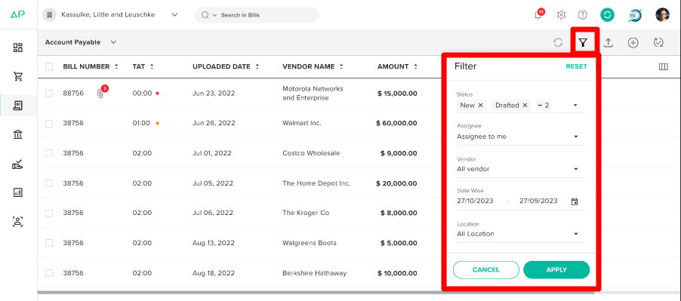

1. **Filter**

* It Allows users to filter bills based on various criteria. The available filters are:
  + **Status**
    - Users can select from options like "New," "Drafted," "Bill rejected", “Bill Approval Requested”, "Bill failed," "Approval sent," "Sent”, Bill Approved” and "Deleted."
    - By default, status like "New," "Drafted," "Bill rejected”," "Bill failed," should be selected.
  + **Assignee**:
    - Users can filter bills as "Assigned to me," "Assigned to other," or "Unassigned."
    - By default, "Assigned to me” should be selected.
    - Whenever “Assigned to other” is selected, a "Select user" field should appear below it. This field will display only those users who are assigned, and it will be multi-selectable.
  + **Vendor:** 
    - The dropdown list should contain list of vendors available in the company.
    - By default, "All vendors" should be selected and It will be multi selection.
  + **Date Range**:
    - Users can set a date range for filtering bills.
    - By default, it is set to the “Last one month” to the “Current date”.
  + **Location:** 
    - The dropdown list should contain a list of locations available in the company.
    - By default, "All Locations" should be selected.
* At the top of the filter popup, there shall be a "RESET" button, which resets all applied changes in filter fields.
* At the bottom of the filter popup, there shall be “APPLY” button, which should apply the filter in listing screen.
* When the "Other" process is selected, the "Status" and "Assignee" fields in the filter should not be displayed

1. **File Upload**

* For a complete understanding of the file upload process, please refer to the "File Upload" ldocumentation. [File Upload_JM_0.0.1.docx](https://pacificglobalsolutions-my.sharepoint.com/:w:/r/personal/jayraj_mourya_technomark_io/Documents/File%20Upload_JM_0.0.1.docx?d=wa577f871e31d425db2e017697458f570&csf=1&web=1&e=hLu1KW)

1. **Create**

* The "Create" option is used to create an Account Payable (AP) or Account Adjustment (AD) without a bill. Upon clicking "Create," users will see two options:
  + Account Payable
  + Account Adjustment

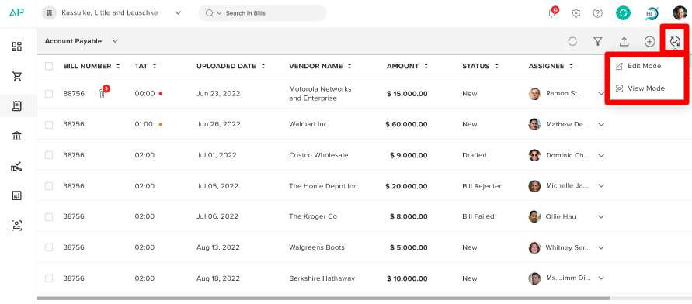

1. **Mode**

* The "Mode" dropdown provides two modes:
  + View Mode: Allows user to view bills.
  + Edit Mode: Allows users to make edits to bill information
* By default, List mode should always be displayed.

**Table**

The Bill Posting listing screen shall displays the following default columns with sorting option:

* Bill Number:
  + This column will show the bill number, and if the bill contains an attachment, it will display an icon indicating the count of an attachment.
  + Clicking on this icon will show both the bill and attached documents
* TAT
  + This column displays the Turnaround Time for the bill.
  + The “Red” dot beside the TAT number shall indicate the Missed bill
  + The “Orange” dot beside the TAT number shall indicate the 25% pending.
* Uploaded Date:
  + The date when the bill was uploaded, presented in the format "Mon Date, Year."
* Vendor Name:
  + The name of the vendor associated with the bill.
* Amount:
  + The total amount of the bill.
* Status:
  + The current status of the bill.
* Assignee:
  + The user assigned to the bill
  + In the "Assignee" column for each line item, a dropdown will be available.
  + It shall display search bar with a list of company users and allows for single selection, enabling users to change the assignee for a specific bill
* The default sorting of the list should be based on the bill with the shortest TAT.
* The list shall initially display a set of maximum 70 records or bills with a lazy loading mechanism, and subsequently, pagination will be implemented to manage the presentation of additional data.

**Column Selection**

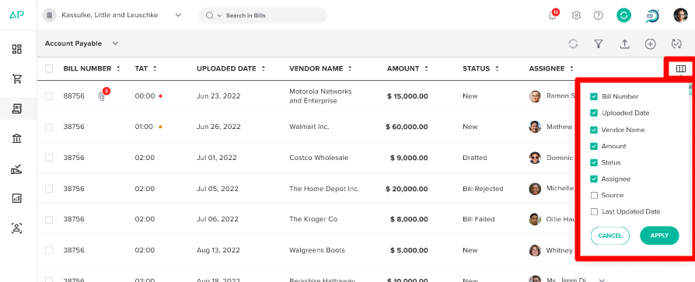

* At the end of the table heading, there shall be a "Column Selection" icon. Clicking this icon will display a list of all available columns with checkboxes. Users can select the columns they want to display. Additionally, apart from default columns there shall be two more columns available in the list
  + Source: Indicates the source of the bill (Cloud, Email, or File Upload).
  + Last Updated Date: The date when the bill was last updated.
  + Last updated by: Name of user who has made the last change.
* In the dropdown list, when a user makes changes in column selection, an "Apply" button and a "Cancel" button will be available. Clicking "Apply" will save the changes and update the column display accordingly.

## **Multi Selection**

* In the listing screen, when a user selects the checkboxes for multiple bills, the options become accessible at the top right corner of the header. These options are as follows.
* On Multi selecting bills, if assigned to other is selected in filter than action should display based on the permission given.
* On multi selecting bills with different status only View option to be displayed.
  + For New, Draft, Bill rejected, and Bill failed- Edit ,Delete and View option should display.
  + For Sent, Approval sent, and Bill approval requested - View option should display.

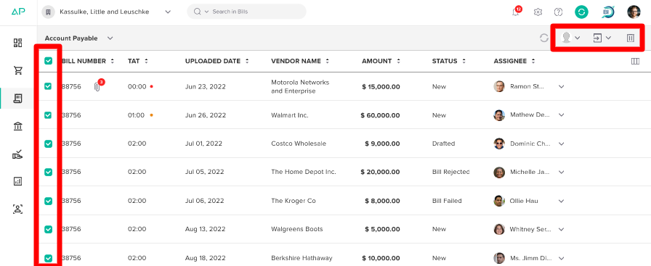

1. **Assignee**:

* This option should be present on top header upon multi selecting bills having “New” and “Draft” status and on each line item.
* This option allows the user to assign multiple selected bills. Upon clicking this option, a dropdown list will be displayed, showing a search bar with list of available users within the company. The user can then single select the desired assignee for the chosen bills.
* On changing the assignee, a toaster message should appear as “Assignee has been changed successfully”.
* When the bill status is “NEW” than only “Assignee” can be changed.
* It shall be based on the permission/rights.

1. **Move to:**

* The "Move to" option provides the ability to relocate multiple bills to a different process category.
* The specific available options depend on the currently selected process:
* If the "Account Payable" process is chosen, the "Move to" dropdown will contain two options: "Account Adjustment" and "Other."
* If the "Account Adjustment" process is selected, the "Move to" dropdown will offer "Account Payable" and "Other" as options.
* The "Move to" option is also available individually for each bill.
* When the bill status is “NEW” and “Draft” then only user can perform “Move” action.
  + If a draft bill is moved, it should be treated as having a "New" status for the process through which the bill is being moved.

1. **Delete:**

* The "Delete" option is available for removing multiple selected bills. When a user selects this option, an alert box will appear where user will mandatorily have to add the reason and with a confirmation message. The message for the alert box should be something like: "Are you sure you want to delete the selected bills? This action cannot be undone." Users will have the choice to confirm or cancel the deletion process.
  + The reason field should allow alpha numeric character maximum up to 200 character.
* If clicked Yes, the bills will be soft delete and it will move under DELETED status.
  + On filtering deleted files, user will get only restore action
  + User can restore the deleted bills up to 30days after that it shall be removed.
  + User will not get Restore option once the bill is successfully posted in accounting tool
* The "Delete " option is also available individually for each bill.
* The Delete option should be available for bills having status like New, Drafted, Bill Failed, Bill Rejected.

## **Other Process**

* When Other process is selected the table column should display “Bill Number”, “Uploaded date”, “Vendor” and “Amount”.
* In header there will be two options like Filter and Create.
* Filter should contain fields like Vendor, Date range and Location
* On each line-item user can perform action like “Move” and “Delete” and “View bill”
  + On multi selection of bill, user will get action like “Move” and “Delete” in header.
  + On click of move user shall get option of “Account payable” and “Account adjustment”

## **View Mode**

* Users shall have the option to access the "View Bill" feature for individual bills, which can be accessed by clicking on the respective bill.
* Additionally, the "View Mode" can be activated by selecting "Mode" >> "View Mode," located in the top-right corner of the screen.
* When a user clicks "View Bill" for a specific bill, it will provide a detailed view of that particular bill.
  + On viewing bill having “Draft” status than the name of button below of the screen should display “Drafted” and the button should be disabled in view mode.
* If choosing "View Mode" from the top right corner will initiate the viewing mode of the first bill in the list.

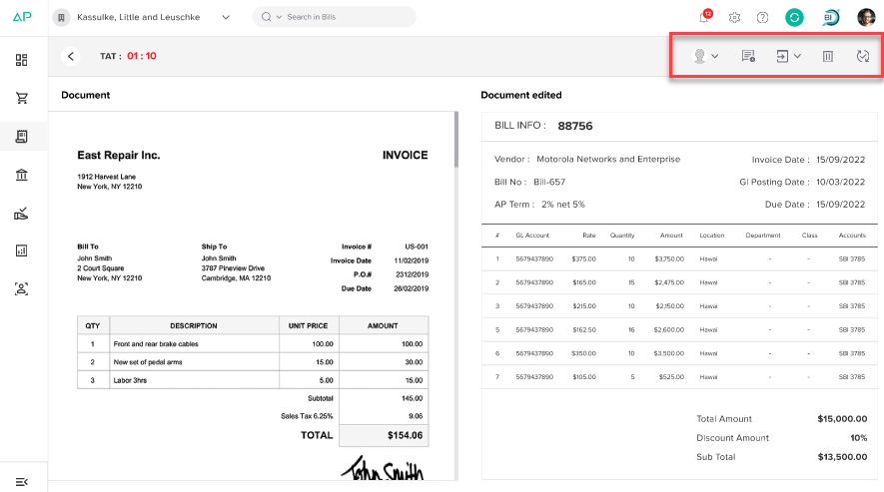

* User can only get view action for Bills having statuses like Sent, Bill Approval requested, Approval sent.
* In the View Mode, users shall get options like as shown in above screen
  + **Reassign**:
    - Similar to the "Assignee" functionality mentioned earlier, users can reassign the bill to a different assignee while in View Mode.
  + **Activities**:
    - The Activities section provides a comprehensive bill history and allows users to add or view comments related to the bill. The Activities screen is structured into three tabs:
    - “ALL” tab (Default): The "All" tab is selected by default, offering a combined view of both bill history and comments.
    - “History” tab: Here, users can review the complete history of the bill, which provides insights into its journey and various actions taken.
    - “Comments” tab: This tab exclusively displays comments added by users pertaining to the bill.
    - Tagging Users in Comments: When a user tags another user while adding a comment, the tagged user will receive an email notification. Moreover, if the tagged user responds to the comment, the reply will be displayed in the comments section.
    - Adding Watchers: At the bottom left of the chat, there is an option to add watchers to the bill. Users can select multiple watchers from a list of available company users.

**Note**: Watcher will not be able to Reply or add comments

* + - Additionally, users have the ability to attach files to the chat for further documentation and reference.
    - User can add 5 files and the added files can be viewed as well.
  + **Move to:** 
    - Bills can be relocated to a different process directly from View Mode. Same as mentioned above in document
  + **Delete**:
    - Similar to the "Delete" functionality mentioned earlier in listing screen
  + **Mode**:
    - Users can toggle between "List Mode" and "Edit Mode" directly from the View Mode. Choosing "List Mode" will navigate the user back to the main list screen.

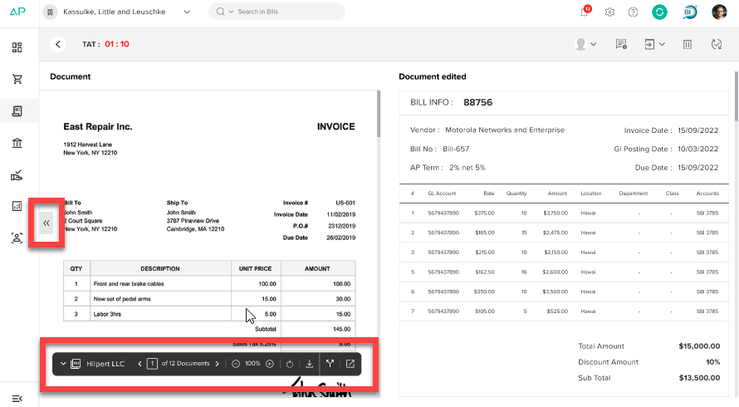

* On Hovering over a PDF document will trigger the display of a "PDF Toolbar" along with options to "Split" the document and "Open the bill in a new screen."
  + When the user clicks the "Open in new screen" switch, one screen will display the bill details, and the other screen will show the PDF view. So, if the user clicks the Post button on the screen with bill details and the bill gets posted, the next bill should appear on both screens. In other words, this process will continue until the "Open in new screen" switch is turned off.
  + The "Split" icon should be made available for use when there are multiple pages within a document
  + Upon clicking Split icon, a screen should slide from right as shown below.

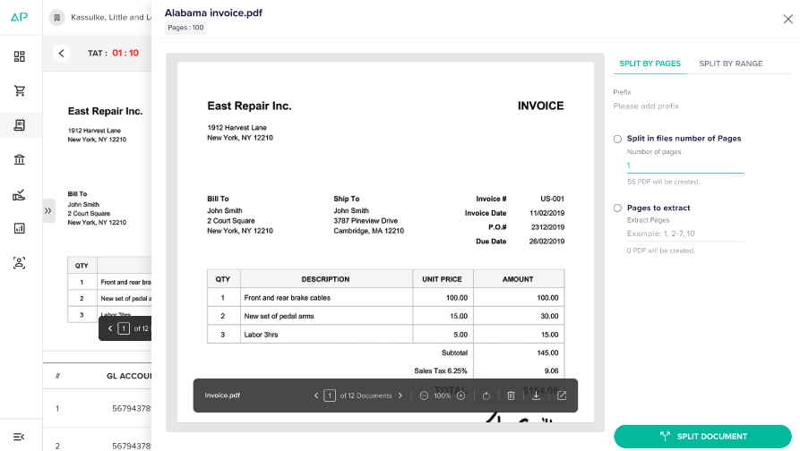

* + The screen should contain two tabs: “Split by pages” and “Split by range”.
  + In “Split by pages” tab, there should be Prefix field, two radio button field “Split in files number of pages” and “Pages to extract”
  + In “Split by range” tab, there should be Prefix field, a table to set range with remove icon and below it Add range button for additional range.
  + Upon clicking “Split document” button, the automation process should start and new TAT should start.
  + When a user performs the "Split" action, assign the split files to that user automatically.
* An expand/collapse icon appears when hovering over a PDF. Clicking on this icon will open a panel from the right, displaying a list of all bills. This panel includes checkboxes for multiple bill selection, a process selection dropdown, and options for filtering and merging bills.
  + Filters will be same as mentioned above in bill posting listing screen.
* The "Merge" option allows users to combine selected bills. This feature is enabled when multiple bills are selected

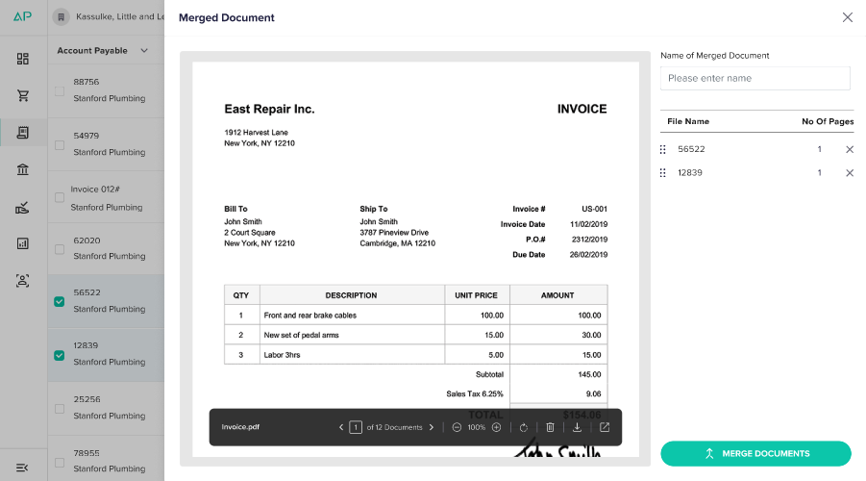

* + Upon clicking “Merge” icon a screen should slide out from right as shown above
  + User will have to enter the “Name of merged document”. The field should allow maximum up to 20 alpha numeric character.
  + List of selected files will display with File name and No. of pages along with remove “X” icon on each line item of file. On clicking X icon, the file should be removed.
    - Users shall not remove all the files. Minimum two files should be present to perform merge action.
  + Upon clicking “Merge document” button the automation process of the merged file should start and new TAT should start.

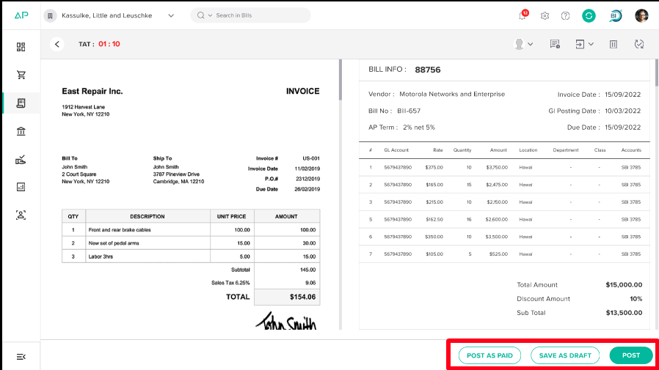

* There shall be three buttons at bottom of the screen as mentioned below (shall be based on permission/rights)
  + Post as paid
    - It indicates that the bill should be posted in the accounting tool and considered as paid status.
    - Upon clicking the button, a popup shall open which should contain below fields
      * Payment Method: A dropdown field to single select the below enabled payment method.
        + Record Transfer
        + Cash
        + Credit card
      * Bank Account: A dropdown field should display list of banks based on the selected payment method
      * Payment Date
        + A calendar should open which allows user to select the payment date and it should not allow future date selection.
  + Save as draft
  + Post
    - If the bill is successfully posted in the accounting tool after pressing the "Post" button, it will be removed from the bill posting screen and relocated to the Bills to pay screen.
* There should be “Previous <” and “Next >” arrow to move in bills.

## **Edit Mode**

* The "Edit Mode" can be activated by selecting "Mode" >> "Edit Mode," located in the top-right corner of the screen.
* If choosing "Edit Mode" from the top right corner will initiate the editing mode of the first bill in the list.

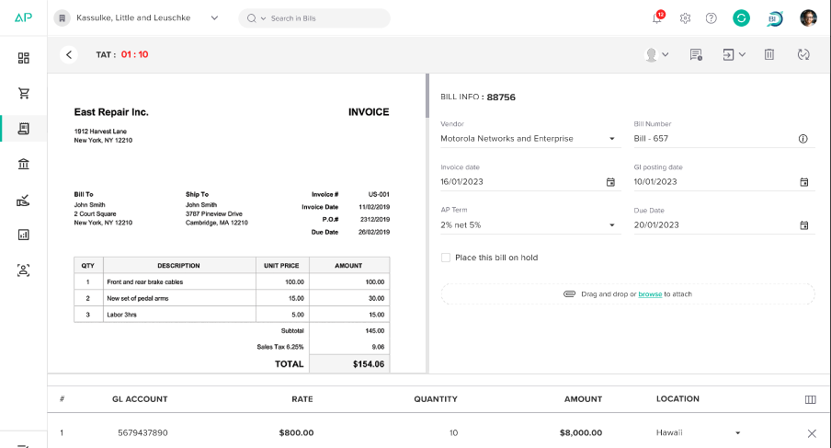

* The “Edit "option should be available for bills having status like “New, Drafted, Bill Failed, Bill Rejected”.
* In the Edit Mode, users shall get options like as below
  + Reassign:
    - Similar to the "Assignee" functionality mentioned earlier, users can reassign the bill to a different assignee while in edit Mode.
    - On changing the assignee an alert message should appear as “Are you sure you want to reassign? Yes or No
      * On Yes, the reassigned bills shall be removed, and screen should get reload.
  + Activities:
    - The Activities section provides a comprehensive bill history and allows users to add or view comments related to the bill. The Activities screen is structured into three tabs:
    - “ALL” tab (Default): The "All" tab is selected by default, offering a combined view of both bill history and comments.
    - “History” tab: Here, users can review the complete history of the bill, which provides insights into its journey and various actions taken.
    - “Comments” tab: This tab exclusively displays comments added by users pertaining to the bill.
    - Tagging Users in Comments: When a user tags another user while adding a comment, the tagged user will receive an email notification. Moreover, if the tagged user responds to the comment, the reply will be displayed in the comments section.
    - Adding Watchers: At the bottom left of the chat, there is an option to add watchers to the bill. Users can select multiple watchers from a list of available company users.

**Note**: Watcher will not be able to Reply or add comments

* + - Additionally, users have the ability to attach files to the chat for further documentation and reference.
    - User can add 5 files and the added files can be viewed as well.
  + Move to:
    - Bills can be relocated to a different process directly from the View Mode. Same as mentioned above in document
  + Delete:
    - Similar to the "Delete" functionality mentioned earlier in listing screen
  + Mode:
    - Users can toggle between "List Mode" and "View Mode" directly from the Edit Mode. Choosing "List Mode" will navigate the user back to the main list screen.
* Following fields are editable

**Main Fields**

* + Vendor
  + Bill number
  + Date
  + GL Posting date
  + Reference number
  + Term
  + Due date
  + Description
  + Place this bill on hold
    - If checked than “Post as paid” should be disabled.

**Line-item fields**

* + GL Account
  + Rate
  + Quantity
  + Amount
  + Location
* On performing any change and user is changing the move or moving to different screen than a alert message should appear as “Do you want to save the changes”
  + Yes
  + No
* Users can add new line items or remove the existing line item.
* Hovering over a PDF document will trigger the display of a "PDF Toolbar" along with options to "Split" the document and "Open the bill in a new screen."
  + When the user clicks the "Open in new screen" switch, one screen will display the bill details, and the other screen will show the PDF view. So, if the user clicks the Post button on the screen with bill details and the bill gets posted, the next bill should appear on both screens. In other words, this process will continue until the "Open in new screen" switch is turned off.
  + The "Split" icon should be made available for use when there are multiple pages within a document
  + Upon clicking Split icon, a screen should slide from right as shown below.
  + The screen should contain two tabs: “Split by pages” and “Split by range”.
  + In “Split by pages” tab, there should be Prefix field, two radio button field “Split in files number of pages” and “Pages to extract”
  + In “Split by range” tab, there should be Prefix field, a table to set range with remove icon and below it Add range button for additional range.
  + Upon clicking “Split document” button, the automation process should start and new TAT should start.
  + When a user performs the "Split" action, assign the split files to that user automatically.
* An expand/collapse icon appears when hovering over a PDF. Clicking on this icon will open a panel from the right, displaying a list of all bills. This panel includes checkboxes for multiple bill selection, a process selection dropdown, and options for filtering and merging bills.
  + Filters will be same as mentioned above in bill posting listing screen.
* The "Merge" option allows users to combine selected bills. This feature is enabled when multiple bills are selected
  + Upon clicking “Merge” icon a screen should slide out from right as shown above
  + User will have to enter the “Name of merged document”. The field should allow maximum up to 20 alpha numeric character.
  + List of selected files will display with File name and No. of pages along with remove “X” icon on each line item of file. Clicking X icon, the file should get removed.
    - Users shall not remove all the files. Minimum two files should be present to perform merge action.
  + Upon clicking “Merge document” button the automation process of the merged file should start, and new TAT should start.
* There shall be three buttons at bottom of the screen as mentioned below (shall be based on permission/rights)
  + Post as paid
    - It indicates that the bill should be posted in the accounting tool and considered as paid status.
    - Upon clicking the button, a popup shall open which should contain below fields
      * Payment Method
        + A dropdown field to single select the below enabled payment method
      * Record Transfer
        + Cash
        + Credit card
        + Bank Account

A dropdown field should display list of banks based on the selected payment method

* + - * Payment Date
        + A calendar should open which allows user to select the payment date and it should not allow future date selection
  + Save as draft
  + Post
    - If the bill is successfully posted in the accounting tool after pressing the "Post" button, it will be removed from the bill posting screen and relocated to the Bills to pay screen.
* There should be “Previous <” and “Next >” arrow to move in bills

## **Create >> Account Payable**

* Unlike the standard AP processing having actual bill, in this there will be no PDF view of the bill. Users will need to manually input the following details as shown in below reference screen

**Main Field**

* The standard available fields are as below
  + Date*: Users must enter the date of purchase. It is a mandatory field.
  + GL Posting Date: Initially auto-filled based on the bill date but can be manually change by the user.
  + Vendor*: A dropdown field will list all added vendors. Selecting a vendor will be mandatory and will auto-fill the "Term" field, which is captured during vendor creation.
  + Reference Number: User can enter the reference number if available. The field should allow maximum of 20 alpha numeric character
  + AP Term: It Will get autofill based on vendor selection. User can change the term by selecting it from the dropdown field.
    - If any discount related term is selected than a checkbox of “Discount applicable” should appear.
    - On selecting the checkbox, “Discount line item” row and “Add separate adjustment entry” checkbox should appear.
  + Due Date*: Automatically calculated based on the selected term and bill date. It is mandatory field. Users can also manually change the due date.
  + Bill Number*: To input the bill number. It is a mandatory field, and the field should allow maximum of 20 alpha numeric character.
  + Description: User can add description of bill. The field should allow maximum 150 Alpha numeric character
  + Attachment: Users can attach up to five files, with a maximum size of 50MB
    - There should be remove icon to remove the attached document
  + Place Bill on Hold: A checkbox is available. Selecting this checkbox means that the bill will be processed and posted in the accounting tool, but the payment entry will be kept on hold until further action is taken
    - If selected, the “Post as paid” button should be disabled.

**Line-Item Fields**

* At the bottom of the screen, there is a section for line items. This section includes the following standard columns
  + GL Account*: A dropdown field listing all the GL (General Ledger) accounts. It is mandatory field
  + Rate: It shall allow 10 digit and two decimal places. This field shall appear when PO is turned on for the company.
  + Quantity: It should allow max up to max 500 numeric value. This field shall appear when PO is turned on for the company
  + Amount*: It should be calculated as Rate * Qty otherwise Users can enter the amount for each line item. It is mandatory field and allows up to 15 digits.
  + Location: A dropdown field listing all the available locations for the company.
  + Department: A dropdown field listing all the available department for the company
  + Class: A dropdown field listing all the available classes for the company
* Based on the field mapping setup, the column should display.
* There shall be “Add new line” button on every line item.
  + Once a line item is added there shall be an “x” icon for removing that line item.
  + First line item should not contain “X” remove icon

**Add Separate Adjustment Entry**

* The *Add Separate Adjustment Entry* checkbox will appear when discount related term is selected. Selecting the checkbox will create a separate adjustment entry of the discounted amount.
* A textbox will be display of *Total discount amount* with its value as shown below

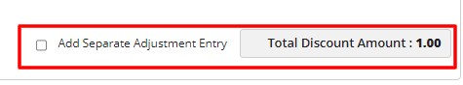

* If user will select checkbox of separate adj. entry, then discounted amount won’t be deducted from Total amount and new adjustment entry will be posted.

**Discount Line-item fields**

* The column would be same available in line-item field, but the amount column should display the value of discount based on the value in line-item *Amount* field as shown in below image

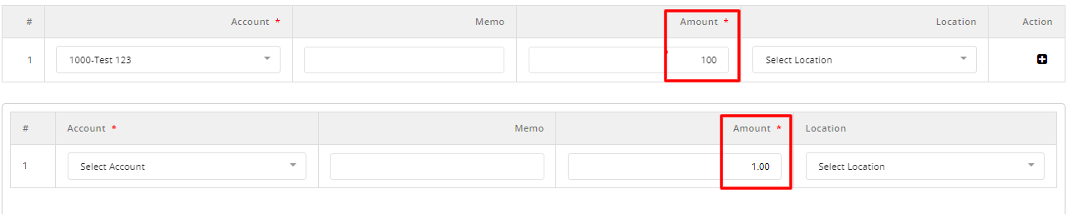

* There shall be three buttons at bottom of the screen as mentioned below
  + Post as paid:
    - It indicates that the bill should be posted in the accounting tool and considered as paid status.
    - Upon clicking the button, a popup shall open which should contain below fields
      * Payment Method
        + A dropdown field to single select the below enabled payment method
      * Record Transfer
        + Cash
        + Credit card
        + Bank Account

A dropdown field should display list of banks based on the selected payment method

* + - * Payment Date
        + A calendar should open which allows user to select the payment date and it should not allow future date selection.
  + Save as draft:
    - The bill will be saved in draft status.
  + Post:
    - If the bill is successfully posted in the accounting tool after pressing the "Post" button, it will be removed from the bill posting screen and relocated to the Bills to pay screen

## **Create >> Account Adjustment**

* Unlike the standard AD processing having actual bill, in this there will be no PDF view of the bill. Users will need to manually input the following details as shown in below reference screen

**Main Field**

* The standard available fields are as below
  + Date*: Users must enter the date. It is a mandatory field.
  + GL Posting Date: Initially auto-filled based on the bill date but can be manually change by the user.
  + Vendor*: A dropdown field will list all added vendors. Selecting a vendor will be mandatory and will auto-fill the "Term" field, which is captured during vendor creation.
  + Reference Number: User can select the adjustment reference number if available.
  + Adjustment Number*: To input the adjustment number. It is a mandatory field and the field should allow maximum of 20 alpha numeric character.
  + Attachment: Users can attach up to five files, with a maximum size of 50MB
    - There should be remove icon to remove the attached document

**Line-Item Fields**

* At the bottom of the screen, there is a section for line items. This section includes the following standard columns
  + GL Account*: A dropdown field listing all the GL (General Ledger) accounts. It is mandatory field
  + Rate: It shall allow 10 digit and two decimal places. This field shall appear when PO is turned on for the company.
  + Quantity: It should allow max up to max 500 numeric value. This field shall appear when PO is turned on for the company
  + Amount*: It should be calculated as Rate * Qty otherwise Users can enter the amount for each line item. It is mandatory field and allows up to 15 digits.
  + Location: A dropdown field listing all the available locations for the company.
  + Department: A dropdown field listing all the available department for the company
  + Class: A dropdown field listing all the available classes for the company.
* Based on the field mapping setup, the column should display.
* There shall be “Add new line” button on every line item.
  + Once a line item is added there shall be an “x” icon for removing that line item.
  + First line item should not contain “X” remove icon
* There shall be three buttons at bottom of the screen as mentioned below
  + Post as paid:
    - It indicates that the bill should be posted in the accounting tool and considered as paid status.
    - Upon clicking the button, a popup shall open which should contain below fields
      * Payment Method
        + A dropdown field to single select the below enabled payment method
      * Record Transfer
        + Cash
        + Credit card
        + Bank Account

A dropdown field should display list of banks based on the selected payment method

* + - * Payment Date
        + A calendar should open which allows user to select the payment date and it should not allow future date selection.
  + Save as draft:
    - The bill will be saved in draft status.
  + Post:
    - If the bill is successfully posted in the accounting tool after pressing the "Post" button, it will be removed from the bill posting screen and relocated to the “Bills to pay” screen

**Note:**

**All screens and option will display based on the permission matrix’s**

**“Activity” option will be taken in other sprint with Bills to pay**